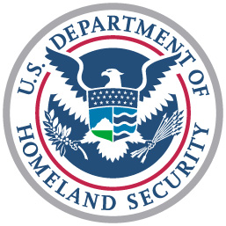 | Captain  Gordon Loebl  United States Coast Guard | 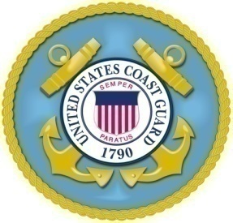
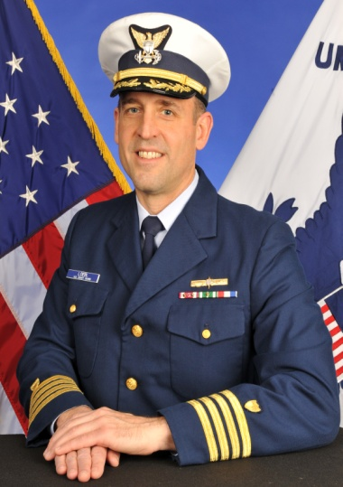
Captain Loebl, a native of Highland Park, Illinois, is a 1984 graduate of the University of Miami in Coral Gables, Florida with a Bachelor of Arts degree in Marine Affairs. In 1987, he graduated from the U.S. Coast Guard Officer Candidate School in Yorktown, Virginia, then reported onboard USCGC Morgenthau in Alameda, California where he served as a deck watch officer for two years. In 1989, Captain Loebl reported to Marine Inspection Office New York where he began his Marine Safety career as an apprentice Marine Inspector conducting safety inspections of commercial vessels throughout the tri-state area, Europe, Africa, and the Middle East during Operation Desert Shield.
In 1991, Captain Loebl reported to Marine Safety Office Honolulu where he served as a Marine Inspector and continued to examine U.S. vessels operating throughout the Far East, India, and Australia. He then assumed the duties of Domestic Inspection Branch Chief responsible for all Coast Guard commercial vessel safety inspections occurring in the Hawaiian Islands. Later in that same tour, Captain Loebl became the Assistant Senior Investigating Officer where he conducted marine casualty investigations across the Aloha State. He also represented the Coast Guard during formal hearings before an Administrative Law Judge to determine if merchant mariners had violated safety regulations or committed acts of misconduct or negligence.
In 1995, Captain Loebl attended the University of Virginia, where he graduated with a Master of Marine Affairs degree. In 1997, he reported to Coast Guard Headquarters and served in the Office of Investigations & Analysis where he developed enforcement regulations and polices related to civil penalties and the Suspension & Revocation process.
From 2000 to 2004, Captain Loebl served as the Chief of Prevention at Coast Guard Activities Baltimore, a prototype command with integrated Group and Marine Safety Office functions that would eventually become the model for Sector commands. During this assignment, Captain Loebl was the lead project officer for reactivation of the Cove Point Liquefied Natural Gas (LNG) facility in Lusby, Maryland, one of the largest LNG facilities in North America, and the return of LNG shipping to the Chesapeake Bay. He also played a key role in coordinating the National Capital Region’s response to the 9/11 terrorist attacks in Washington, D.C.
In 2004, Captain Loebl became the Executive Officer of Marine Safety Office San Francisco Bay in Alameda, California with duties that included Alternate Captain of the Port and Acting Officer in Charge, Marine Inspection for all of Northern California. It was during this assignment that the Coast Guard decided to implement the Sector command construct across the nation. As a result, he became the first Chief of Prevention at Sector San Francisco.
In 2007, Captain Loebl reported to the Coast Guard Personnel Command in Arlington, Virginia where he served as Chief of the Officer Assignments Branch and directly supervised all Assignment Officers. He then returned to Coast Guard Headquarters in 2008 and assumed the duties of Chief, Office of Quality Assurance & Traveling Inspections. In this role, Captain Loebl assisted with development and implementation of the Coast Guard’s comprehensive Marine Safety Improvement Plan which included establishing and leading seven National Centers of Expertise across the country. He also served as Executive Assistant to the Federal On Scene Coordinator in New Orleans, Louisiana for the Deepwater Horizon response effort. He assumed his current duties as Commander, Sector New York, and Captain of the Port of New York and New Jersey in June 2012.
Captain Loebl’s personal awards include three Meritorious Service Medals, two Coast Guard Commendation Medals, and the Department of Transportation’s 9/11 Medal. His wife, Nancy, is from Honolulu, Hawaii. They have two daughters and a chocolate Labrador retriever.

